Marcus J. Anderson

**Social Media Platform:** Instagram

**Number of Advertisers:** 70

**Categories Identified (7):**

Entertainment Venues (e.g. Live Nation Comedy)

Influencers (e.g. Heather McMahan)

Music (e.g. Jack Harlow)

News (e.g. Akron Beacon Journal)

Shopping (e.g. Blackstone Products)

Sports (e.g. NFL Network)

Television/Movies (e.g. Marvel Studios)

**My script on sankeymatic.com:**

Instagram Advertisers [10] Entertainment Venues

Instagram Advertisers [10] Influencers

Instagram Advertisers [10] Music

Instagram Advertisers [10] News

Instagram Advertisers [10] Shopping

Instagram Advertisers [10] Sports

Instagram Advertisers [10] Television/Movies

Entertainment Venues [5] Relevant

Entertainment Venues [1] Not Relevant

Entertainment Venues [4] Way Off

Influencers [3] Not Relevant

Influencers [7] Way Off

Music [3] Relevant

Music [3] Not Relevant

Music [4] Way Off

News [3] Relevant

News [1] Not Relevant

News [6] Way Off

Shopping [5] Relevant

Shopping [1] Not Relevant

Shopping [4] Way Off

Sports [1] Relevant

Sports [3] Not Relevant

Sports [6] Way Off

Television/Movies [4] Relevant

Television/Movies [4] Not Relevant

Television/Movies [2] Way Off

**My data flow graphic:**

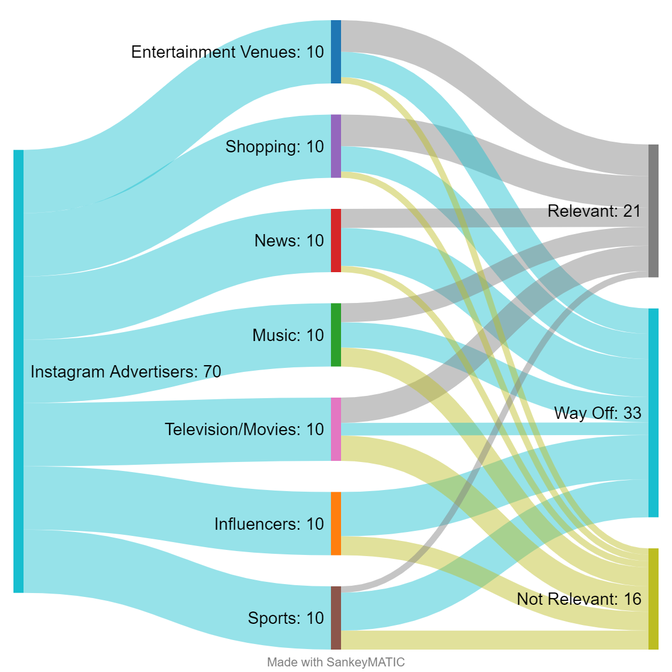

**Table: Summary Statistics**

|  |  |  |  |  |
| --- | --- | --- | --- | --- |
| **Category** | **Data Bucket** | **Count** | **Accuracy** | **Rubbish** |
| Entertainment Venues | Way Off | 4 |  |  |
|  | Not Relevant | 1 |  |  |
|  | Relevant | 5 |  |  |
|  | Total Count | 10 | 50% | 40% |
|  |  |  |  |  |
| Influencers | Way Off | 7 |  |  |
|  | Not Relevant | 3 |  |  |
|  | Relevant | 0 |  |  |
|  | Total Count | 10 | 0% | 70% |
|  |  |  |  |  |
| Music | Way Off | 4 |  |  |
|  | Not Relevant | 3 |  |  |
|  | Relevant | 3 |  |  |
|  | Total Count | 10 | 30% | 40% |
|  |  |  |  |  |
| News | Way Off | 6 |  |  |
|  | Not Relevant | 1 |  |  |
|  | Relevant | 3 |  |  |
|  | Total Count | 10 | 30% | 60% |
|  |  |  |  |  |
| Shopping | Way Off | 4 |  |  |
|  | Not Relevant | 1 |  |  |
|  | Relevant | 5 |  |  |
|  | Total Count | 10 | 50% | 40% |
|  |  |  |  |  |
| Sports | Way Off | 6 |  |  |
|  | Not Relevant | 3 |  |  |
|  | Relevant | 1 |  |  |
|  | Total Count | 10 | 10% | 60% |
|  |  |  |  |  |
| Television/Movies | Way Off | 2 |  |  |
|  | Not Relevant | 4 |  |  |
|  | Relevant | 4 |  |  |
|  | Total Count | 10 | 40% | 20% |

**My most accurate category:** Entertainment Venues and Shopping

**My least accurate category:** Influencers

**Table: Regulated Domain Information**

|  |  |  |
| --- | --- | --- |
| **Regulated Domain** | **Number of Items** | **Advertiser Sample** |
| Credit | 0 |  |
| Education | 2 | SmartAsset.com  BroBible |
| Employment | 10 | Akron Beacon Journal  The Columbus Dispatch |
| Housing | 3 | Zillow Home Loans  Moving.com |
| Public Accommodation | 10 | Live Nation Comedy  Secrets Royal Beach Punta Cana |